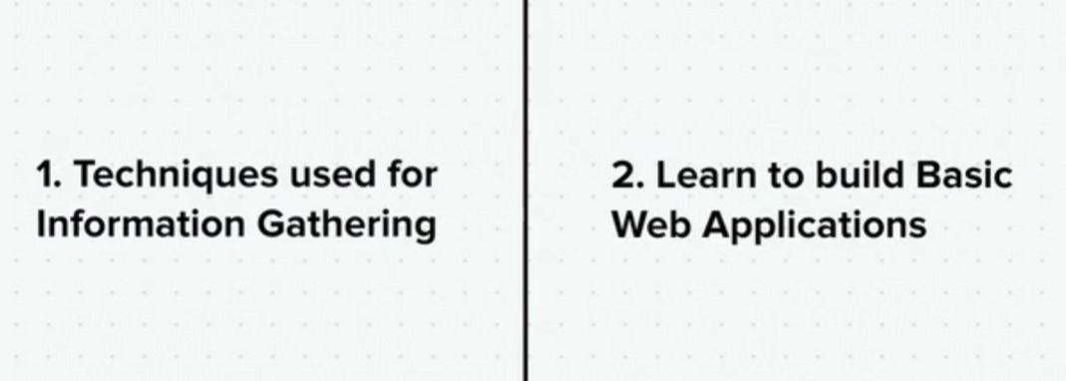

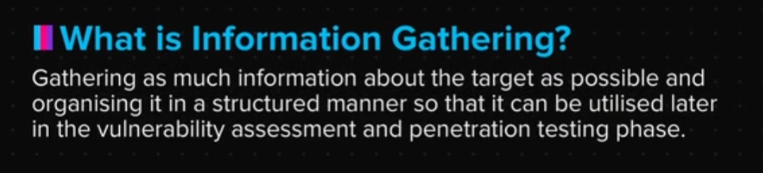

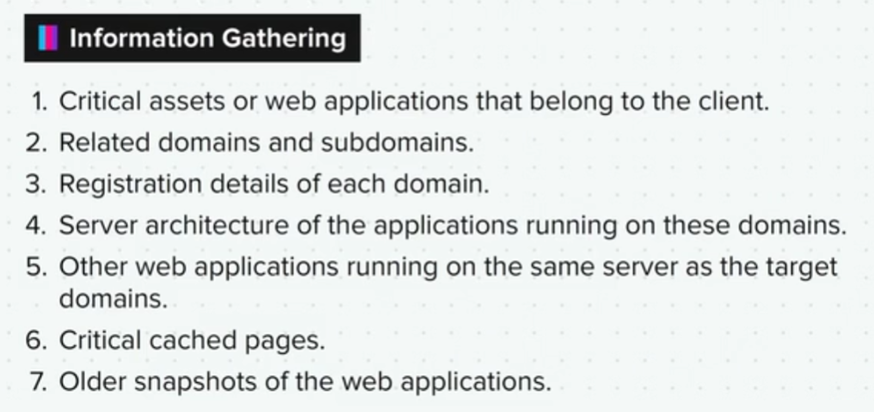

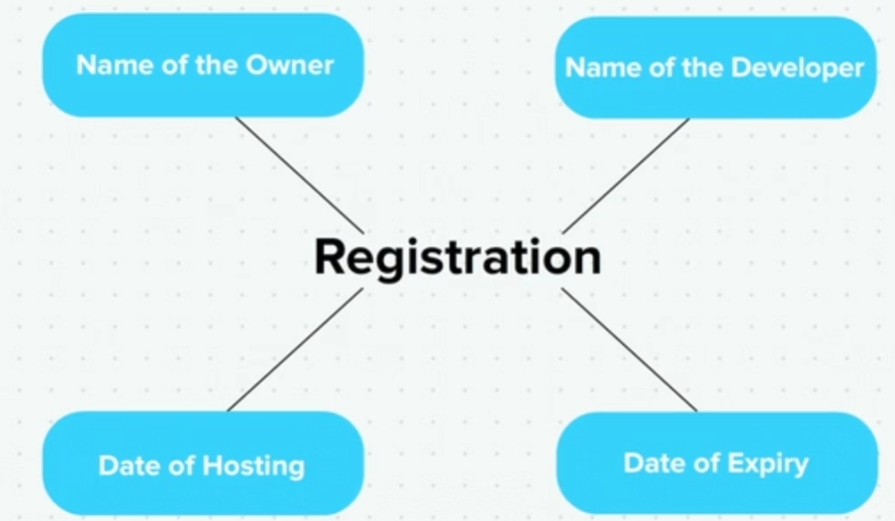

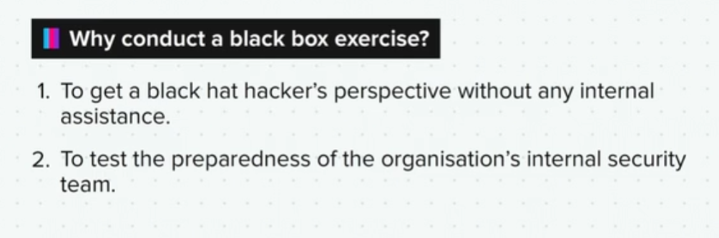

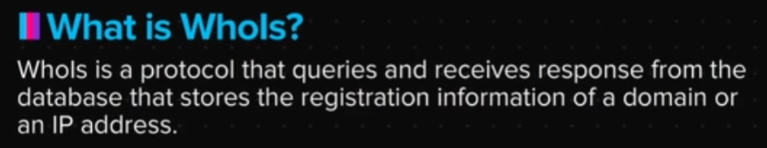

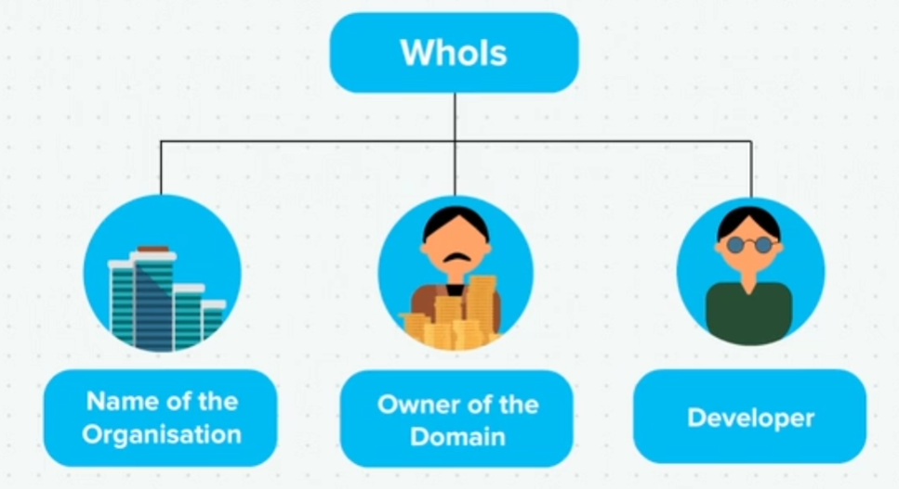

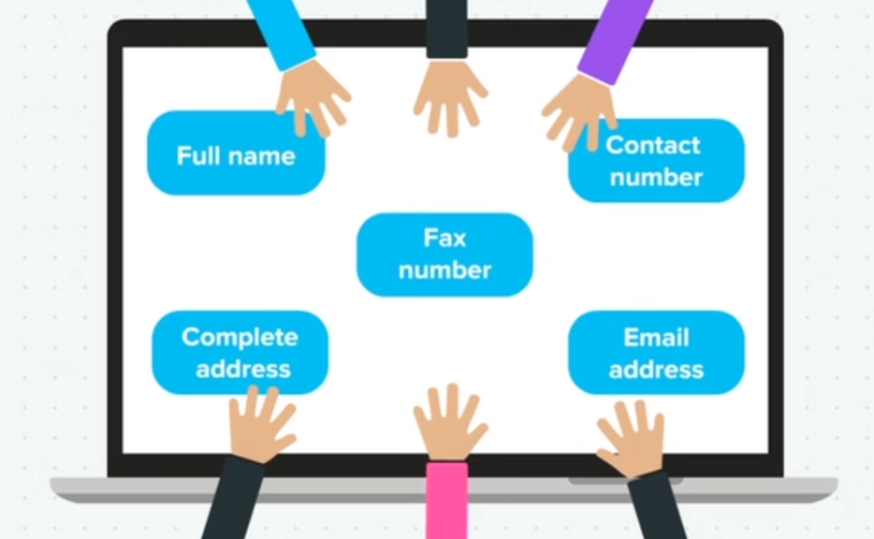

Resources

Here are some links that can be used for the whois lookup.

<https://www.whois.com/whois/>

<https://whois.icann.org/en>

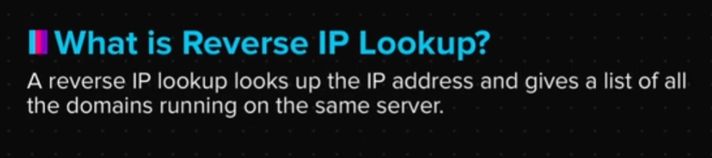

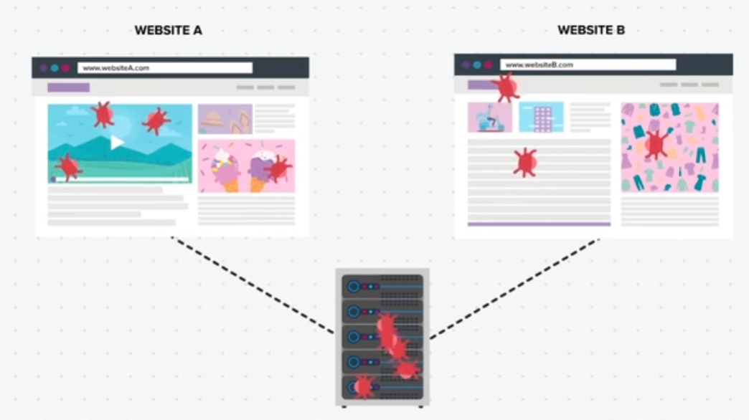

Resources

Here are some links that can be used for the Reverse IP lookup:

<https://mxtoolbox.com/reverselookup.aspx>

<http://viewdns.info/reverseip/>

Summary

Now that we have come to the end of this topic, you should be able to:

1. Explain the concept of digital footprinting

2. Gather Whois information of any website and analyse it

3. Find out other websites running on the shared server of a website